Assignment –6
Using Special Operators in Conditions.
- Write two different queries that would produce all orders taken on October 3rd or 4th, 1990.
Query1:
mysql> select * from orders
-> where odate = '1990-10-03' or odate = '1990-10-04';
Output 1:
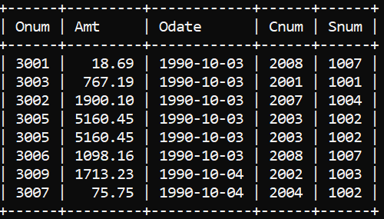
Query2:
mysql> select * from orders
-> where odate between '1990-10-03' and '1990-10-04';
Output2:

- Write a query that selects all of the customers serviced by Peel or Motika. (Hint: the snum field relates the two tables to one another).

Query:
mysql> select * from customers
-> where snum = 1001 or snum = 1004;
Output:
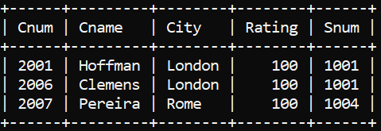

- Write a query that will produce all the customers whose names begin with a letter from ‘A’ to ‘G’.
Query:
mysql> select * from customers
-> where cname like 'A%'
or cname like 'B%'
or cname like 'C%'
or cname like 'D%'
or cname like 'E%'
or cname like 'F%'
or cname like 'G%';
Output:
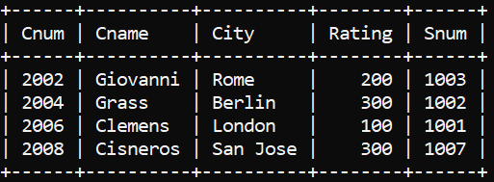
- Write a query that selects all customers whose names begin with the letter ‘C’.
Query:
mysql> select * from customers
-> where cname like 'C%';
Output:
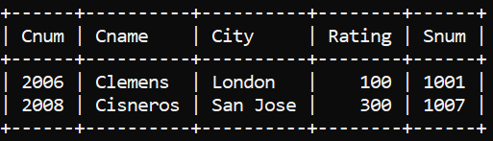

- Write a query that selects all orders except those with zeroes or NULLs in the amt field.
Query:
mysql> select * from orders
-> where amt != 0 or amt != null;
Output:
